AS level economics

Targeted Notes

We will show you how to make targetted notes for your economics exams, which is quite different from classic note-taking. You will be able to pinpoint the most important areas to revise and make relevant notes. You won't be drowned in a sea of notes and be puzzled about where to start! We have categorized the most examined topics from Cambridge Economics (2017 to 2021) past papers. If you are sitting for another exam board (AQA Economics for example) feel free to use this document as a template.

STEP-BY-STEP GUIDE TO NOTE MAKING

Part 1: How to use this document

- Identify keywords

Each economics question contains specific keywords.

Content words cover the whole of the subject area of the syllabus. Their aim is to make clear what is the focus of the question and what you are required to write about.

All content words have been highlighted in different colours.

Here a frequently examined content word is ‘public good’ :

Discuss the view that the only goods a government should produce are public goods.
Explain the features of a public good. Consider whether a motorway (highway) provides an example of a public good

Note that the answers for these two questions will be different despite having the same content words.

This is why it is a bad idea to write pre-prepared answers for your exam!

- Focus on diagrams and definitions

Diagrams relevant to each topic have been included. Provide your own explanations of these diagrams in your own words. This will help you memorise them.

Remember to define all relevant content words in the first paragraph of your essay. We have provided these definitions for you! (All definitions are from Cambridge books)

- Understand the trend

This document can help you to identify the most examined topics and content words in past exam economics essay questions. This will help you to focus your notes towards specific areas instead of re-writing all your notes from A to Z.

- Make notes

Now that you have achieved all of the above steps. Use your knowledge to make targeted notes according to the most examined topics and keywords. This is much more useful than classic notes and this method will pay off!

Tip: Print this document

Feel free to print this document (preferably in colour) as many times as required.

Part 2 : How to make notes

- Examine the highlighted content words

For example here one of the content words is public goods.

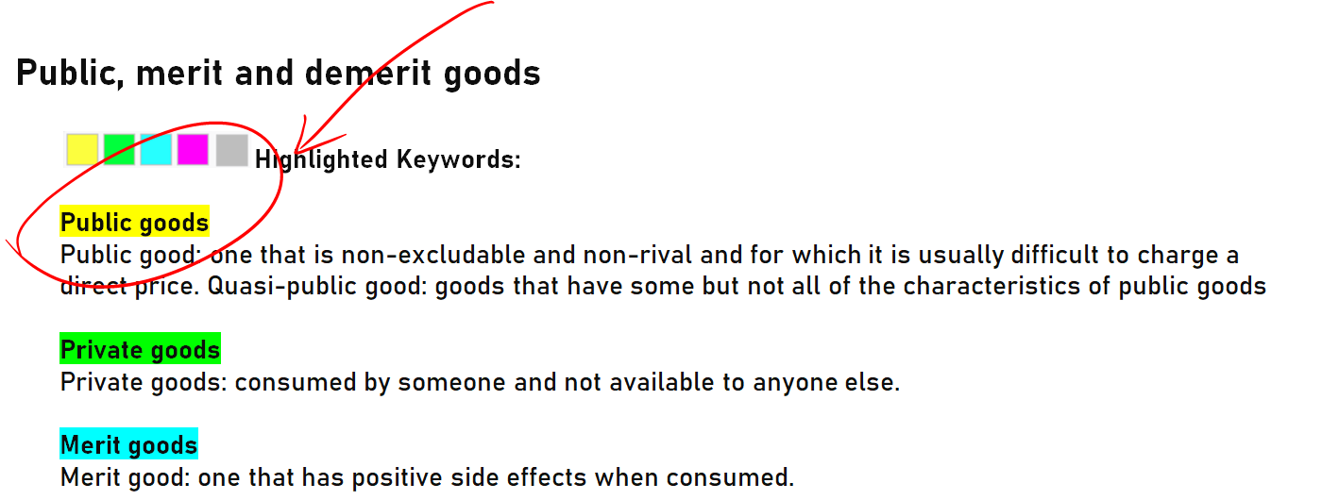

In your notes start by writing a clear definition for this term:

You can use your book or tuition notes as a reference.

- Look in what context the questions are asked

For example: What similarities do these questions have?

Discuss, with the use of examples, whether a government should directly provide certain goods and services in an economy.[12]
Explain the features of a public good. Consider whether a motorway (highway) provides an example of a public good.[8]
Using examples, explain the difference between a merit good and a public good. Explain why a profit can be made from the provision of one of these types of good, but not the other.[8]

They all require you to explain the features of public goods: non-excludable and non-rival.

In your notes, add clear definitions of these two terms

Furthermore, you will notice a trend. It is often asked whether a government should directly provide public goods (and why not the free market).

Those who have revised this chapter know that the 'free-rider problem' must be mentioned. Explain this concept in detail in your notes.

The free-rider problem is a type of market failure that occurs when those who benefit from resources, public goods (such as public roads or hospitals), or services of a communal nature do not pay for them...

- Add diagrams

Include any relevant diagrams to the topic. We have already added some frequently used ones but feel free to add more.

- Remember

Doing the above exercise will help you build your own personal toolbox. During the exam, you will
pick up some knowledge from this toolbox and apply it to your answer.

No two essay answers will be the same, even if the questions are a similar topic. Hopefully, by doing the above exercise, you will conclude that it is a bad idea to write pre-prepared answers for your exam!

Table of contents

Command Words .......................................................................................................................................................3

Most examined topics from 2017 to 2020

Scarcity, choice and opportunity cost 5
Demand and supply 6
Economic structure 7
Public, merit and demerit goods 8
Money 10
Elasticity 11
Tax 15
Subsidy 17
Maximum price and minimum price 18
Aggregate demand and aggregate supply 19
Government intervention 22
Inflation and deflation 24
Exchange rates 26
Terms of trade 28
International trade 29

Command words

There is a difference between, for example, 'state the advantages of' and 'explain the advantages of'

Examination questions are carefully written to test specific knowledge and skills. They never contain questions such as: 'Write all you know about . . . ' or 'Write as much as you can remember about . . . '

Calculate
Work out using the information provided

Define
Give the exact meaning

Describe
Give a description of

Identify
Give an example or key point

Illustrate
Give examples or use a diagram

Outline
Describe the key point without detail

State
Make clear

Analyse
Set out the main points and show how they link and connect

Compare
Explain similarities and differences

Explain
Give clear reasons or make clear

Consider
Give your thoughts about, with some differences

Assess
Show how important something is

Comment upon
Give your reasoned opinions on, with some explanation

Criticise
Give an opinion, but support it with evidence

Discuss
Give the important arguments, for and against, ideally with a conclusion

Justify
Explain why the arguments for an opinion are stronger than the arguments against

Evaluate
Discuss the importance of, making some attempt to weight your opinions

To what extent
Give reasons for and against, come to a conclusion with a justification of which arguments are strongest and which are weakest

And
The word ‘and’ is particularly important in a requirement. It is very easy to read the first part of a requirement, for example ‘Discuss the performance of the business...’ and miss out a further task later on, such as ‘... and state any further information you may find useful

Command words and definitions are extracted from Cambridge AS and A level Economics book

Scarcity, choice and opportunity cost

Highlighted Keywords:

Production possibility curve
Production possibility curve is a simple representation of the maximum level of output that an economy can achieve when using its existing resources in full.

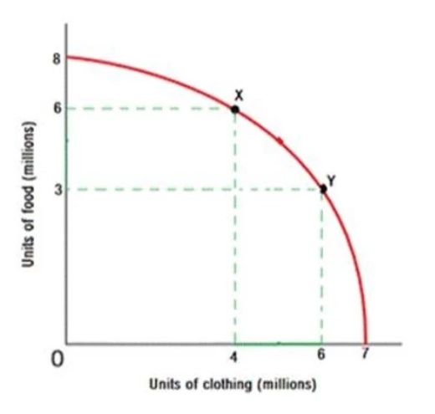

Opportunity cost
Opportunity cost is the cost expressed in terms of the best alternative that is forgone

Questions:

Explain, with the aid of a production possibility curve (PPC) diagram, why scarcity makes choice inevitable for firms and how each choice has an opportunity cost.[8] | 9708/21/M/J/20
Explain, with the help of diagrams, how (i) constant and (ii) increasing opportunity costs determine the shape of an economy’s production possibility curve. [8] | 9708/21/M/J/19
Show how a production possibility curve can be used to explain scarcity, choice and opportunity cost. [8] | 9708/22/F/M/19
Explain how capital goods contribute to production in a modern economy and how capital is rewarded. [8] | 9708/21/O/N/18
Discuss whether enterprise is crucial to the outward shift of the production possibility curve in a mixed economy. [12] | 9708/21/O/N/18
Discuss the effectiveness of supply-side policies in increasing the supply of enterprise to the economy.[12] | 9708/22/M/J/18
Explain how governments face increasing opportunity cost in their decision-making. Use a production possibility curve diagram to support your answer.[8] | 708/22/F/M/18
Use production possibility curves to explain the different impact on an economy of a rise in the unemployment rate and an increase in the working population.[8] | 9708/21/O/N/17
Show the difference between a movement along, and a shift in, a production possibility curve. Explain what might cause each to occur. Use diagrams to support your answer.[8] | 9708/22/O/N/17

Demand and supply

Highlighted Keywords:

Demand and supply
Demand is the quantity of a product that consumers are willing and able to buy at different prices . Supply is the quantity of a product that producers are willing and able to sell at diff erent prices

Equilibrium price and quantity
Equilibrium is a situation where there is no tendency for change. Equilibrium price is the price where demand and supply are equal, where the market clears. Equilibrium quantity: the amount that is traded at the equilibrium price. Disequilibrium: a situation where demand and supply are not equal

Questions:
There is increasing concern about the impact of foreign holidays on the environment of the host country.(a)Explain, with the aid of a demand and supply diagram, two factors that might cause an increase in the demand for foreign holidays.[8] | 9708/21/M/J/20
Explain, with the help of a diagram, the process through which the equilibrium price and equilibrium quantity of a good changes when there is an improvement in the technology underlying the production of that good. [8] | 9708/22/O/N/19
Explain the way in which economists measure how much the supply of a good changes as its price changes. Explain two factors that influence the result.[8] | 708/22/F/M/18
Distinguish between equilibrium and disequilibrium in the market for a good. Explain how equilibrium price and equilibrium quantity will change when there is a decrease in the supply of a product. Use a diagram to support your answer.[8 | 9708/21/O/N/17
Explain how equilibrium price and equilibrium quantity change to allocate resources when there is a successful advertising campaign for a normal good.[8] | 9708/21/M/J/17

Economic structure

Highlighted Keywords:

Economic structure is the way in which an economy is organized in terms of sectors.

Market economy
Market economy: one where most decisions are taken through market forces.

Planned economy
Command or planned economy: one where resource allocation decisions are taken by a central body.

Mixed economy
Mixed economy: one where market forces and government, private and public sectors are involved in resource allocation decisions.

Questions:

Discuss what the most significant issues of transition are that a country will face as it moves from a planned economy to a mixed economy.[12] | 9708/21/M/J/19
Explain the different ways in which resources are allocated in a market economy and in a mixed economy.[8] | 9708/22/M/J/18
Discuss whether the advantages of privatising an industry will always outweigh the disadvantages.[12] | 9708/21/M/J/19
Discuss the way in which resources are allocated in planned economies and free market economies. Consider which type of economic system is likely to have the more beneficial outcome.[12] | 9708/22/O/N/17
Explain the role of the factor enterprise in allocating resources in a market economy when there is an increase in the demand for a good. Use a diagram to support your answer.[8] | 9708/22/M/J/17
Discuss whether decision-making is more effective when undertaken by governments in a planned economy rather than by individuals in a free market economy.[12] | 708/22/F/M/18

Public, merit and demerit goods

Highlighted Keywords:

Public goods
Public good: one that is non-excludable and non-rival and for which it is usually difficult to charge a direct price. Quasi-public good: goods that have some but not all of the characteristics of public goods

Private goods
Private goods: consumed by someone and not available to anyone else.

Merit goods
Merit good: one that has positive side effects when consumed.
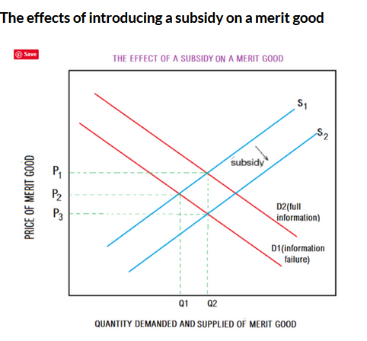

Demerit goods
A demerit good is a good which has adverse side effects when consumed

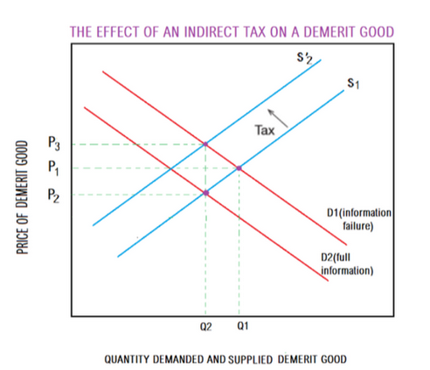

Questions:

a) State what is meant by a demerit good, and with the help of a diagram(s) explain how a tax on producers can improve the allocation of resources in the market for sugar sweetened drinks  b)Compare the likely effectiveness of a policy of imposing minimum prices on demerit goods with one other policy to improve public health and consider which policy is more likely to be successful. | 9708/22/M/J/21
Discuss, with the use of examples, whether a government should directly provide certain goods and services in an economy.[12] | 9708/21/O/N/19
Explain the features of a public good. Consider whether a motorway (highway) provides an example of a public good.[8] | 9708/22/O/N/18
Explain why both merit goods and demerit goods are examples of private goods. [8] | 9708/21/M/J/1
Explain the difference between public goods and private goods. Consider why profit can be made through the supply of one type of good, but not the other.[8] | 9708/22/F/M/17
Discuss why merit goods may be under-consumed in a mixed economy. Consider whether maximum prices or education campaigns would be more effective in ensuring that these goods are supplied in appropriate quantities.[12] | 9708/22/F/M/17
Discuss two methods of increasing the provision of merit goods in a mixed economy. Consider which is more likely to be effective.[12] | 9708/22/M/J/17
Using examples, explain the difference between a merit good and a public good. Explain why a profit can be made from the provision of one of these types of good, but not the other.[8] | 9708/21/M/J/17
Since the demand for a demerit good such as cigarettes is price inelastic, a tax on the product is a waste of time. What is needed is better awareness amongst consumers of the negative effects of smoking cigarettes.’Discuss this view.[12] | 9708/22/O/N/19
Discuss whether merit goods and demerit goods are best provided by a market economy.[12] | 9708/21/M/J/1

Money

Money

Money is anything that is generally acceptable as a means of payment. Near money: non-cash assets that can be quickly turned into cash.

Questions:

Explain the characteristics that money needs to have in order to perform its functions effectively.[8] | 9708/21/M/J/1
Discuss the likely consequences for an economy of an increase in the money supply.[12] | 9708/21/M/J/1
Explain what is used as money in a modern economy. Consider how an increase in the money supply can cause inflation.[8 | 9708/22/F/M/17

Elasticity

Highlighted Keywords:

Price elasticity
Price elasticity of demand (PED): a numerical measure of the responsiveness of the quantity demanded to a change in price of a product
PED = % change in quantity demanded of a product
%change in price of that product

Price elasticity of supply (PES): a numerical measure of the responsiveness of the quantity supplied to a change in the price of the product
PES = % change in quantity supplied
% change in price
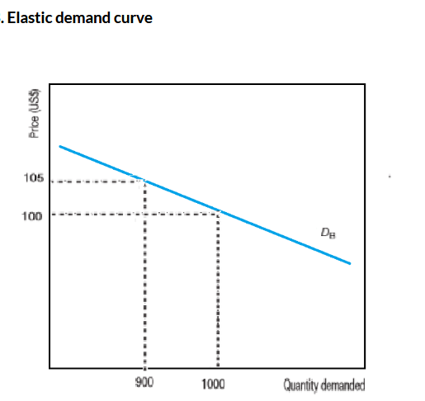

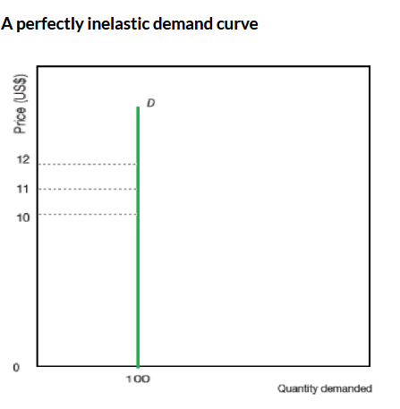

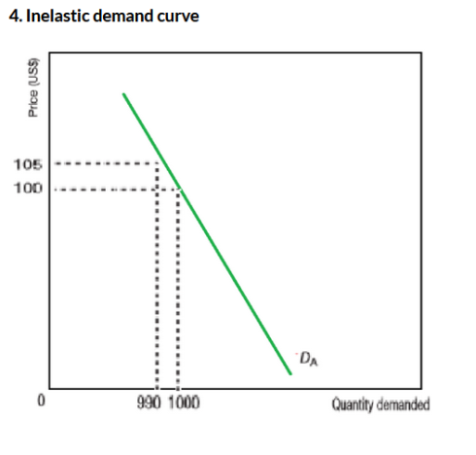

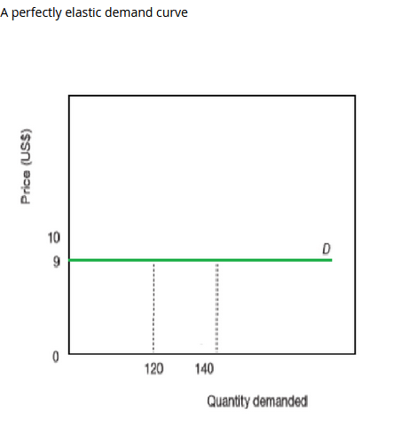

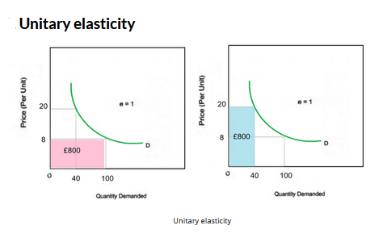
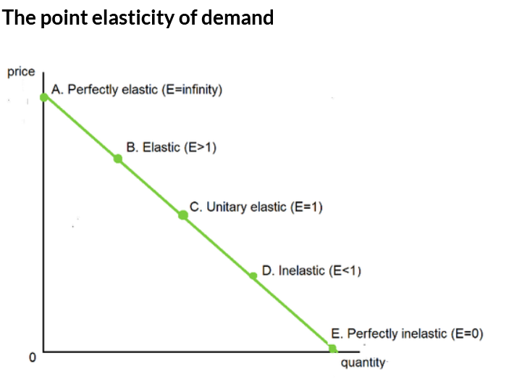
Income elasticity
Income elasticity of demand (YED): a numerical measure of the responsiveness of the quantity demanded following a change in income.
YED = % change in quantity demanded
% change in income
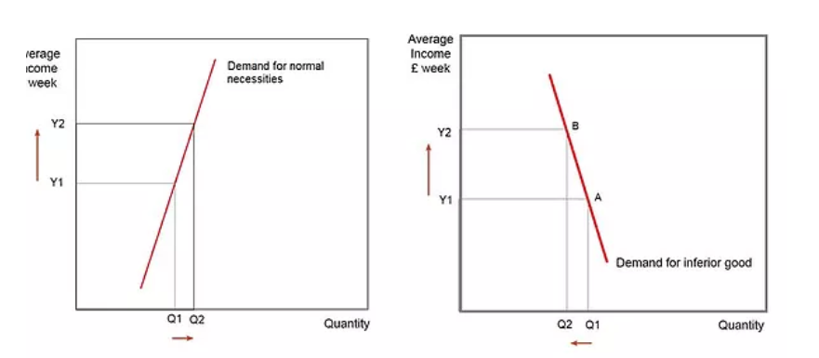

Cross elasticity
Cross elasticity of demand (XED): a numerical measure of the responsiveness of the quantity demanded for one product following a change in the price of another related product.
XED = % change in quantity demanded of product A
% change in the price of product B

Questions:

(a) Explain how the concept of cross-elasticity of demand can be used to distinguish between goods that are substitutes, those that are complements and those that have no relationship. [8]  (b) An economy is experiencing a fall in average incomes during a severe recession. Discuss the extent to which the concepts of income elasticity of demand and price elasticity of demand might be useful to an entrepreneur in this economy and consider which would be more useful. [12] | 9708/22/M/J/21
Discuss, with the use of examples, the extent to which a supermarket could make use of the concept of income elasticity of demand in relation to the different types of goods being sold when there was an increase in consumer incomes.[12] | 9708/21/O/N/19
Explain how knowledge of the price elasticity of demand for a good can help businesses to assess the impact of price changes upon their total revenue.[8] | 9708/22/O/N/19
Explain how knowledge of a good’s price elasticity of demand can help a business to assess the effect of price changes for that good on its total revenue. [8] | 9708/22/F/M/19
Explain the factors that can affect the value of the price elasticity of supply for a product. | 9708/21/O/N/18
Discuss whether income elasticity of demand is the most useful measure of elasticity to a firm. [12] | 9708/21/O/N/18
Explain the significance of cross elasticity of demand values that are negative, positive and zero.[8] | 9708/22/O/N/18
Discuss the extent to which the concepts of price elasticity of demand, income elasticity of demand and price elasticity of supply would be helpful to an organisation responsible for the growth of tourism to a holiday resort. [12] | 9708/22/O/N/18
Explain the factors that can affect the price elasticity of demand for a product.[8] | 9708/21/M/J/1
Discuss the extent to which knowledge of a product’s cross-elasticity of demand is likely to be important to a firm supplying that product.[12] | 9708/21/M/J/1
With the use of diagrams, explain how the price elasticity of demand for a product influences the incidence of an indirect tax on that product.[8] | 9708/22/M/J/18
Explain the factors that determine whether the price elasticity of supply for a good is likely to be relatively elastic or relatively inelastic.[8] | 9708/21/O/N/17
Discuss how governments might attempt to increase the elasticity of supply of an agricultural product. Consider whether they are likely to be successful.[12 | 9708/21/O/N/17
Explain how economists use the concept of income elasticity of demand to distinguish between different types of goods.[8] | 9708/22/O/N/17
Discuss whether an understanding of price elasticity of demand is of more benefit to a producer of agricultural goods than an understanding of income elasticity of demand.[12] | 9708/22/O/N/17
Explain the factors that are likely to make the supply of a product relatively price inelastic. [8] | 9708/22/F/M/17
Discuss the ways in which businesses might attempt to increase the price elasticity of supply of their products. Assess whether these attempts are likely to be successful.[12] | 9708/22/F/M/17
Explain how economists use the concept of elasticity to distinguish between substitute goods and complementary goods. [8] | 9708/22/M/J/17
Discuss which measure of the different types of elasticity of demand is most useful for a business when setting the price for its product.[12] | 9708/22/M/J/17

Tax

Highlighted Keywords:

Indirect tax
Indirect tax is a tax that is levied on goods and services. Example : ad-valorem tax

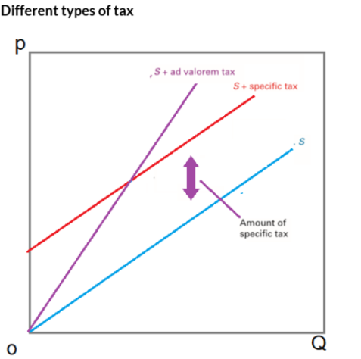
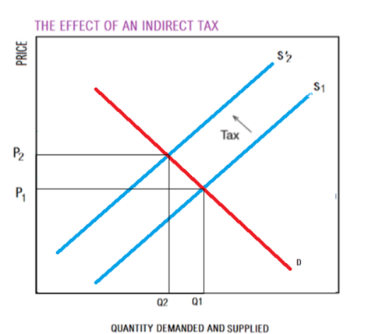

Questions:

There is increasing concern about the impact of foreign holidays on the environment of the host country.(b)Discuss whether an indirect tax on foreign holidays is likely to be effective in reducing the number of holidays taken.[12] | 9708/21/M/J/20
In some countries vaccinations against infectious diseases are offered at a price and payment has to be made If the cost of the subsidy is to be paid from tax revenues, discuss whether the revenue should be raised through direct taxes or indirect taxes.[12. | 9708/22/O/N/20
Indirect taxes reduce consumer surplus and should therefore never be imposed in a mixed economy.’ Discuss this view.[12] | 9708/22/M/J/18
Discuss how the imposition of an indirect tax on a product will affect consumers, the government and producers. Assess whether it will have an overall beneficial effect.[12] | 9708/21/O/N/17
Discuss whether it is better to impose an indirect tax or conduct an awareness campaign to deal with the problem of demerit goods such as alcohol.[12 | 9708/21/M/J/17
Discuss whether indirect taxes and subsidies could be used to improve the consumption of merit and demerit goods if the demand for both of these goods is price inelastic. [12] | 9708/22/F/M/19

Subsidy

Highlighted Keywords:

Subsidy
Subsidies are direct payments made by governments to the producers of goods and services.
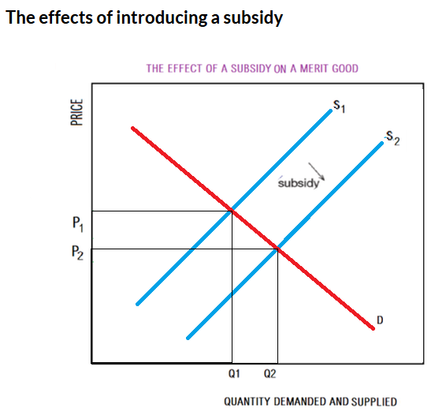

Questions:

In some countries vaccinations against infectious diseases are offered at a price and payment has to be made.(a)Use a diagram to explain how a subsidy given to producers in the market for vaccinations will affect the market price and explain the impact of this subsidy upon the consumer surplus in this market.[8] | 9708/22/O/N/20
Explain, with the help of a diagram, the effect and incidence of a subsidy in a market for essential transport.[8] | 9708/21/O/N/19

Maximum price and minimum price

Highlighted Keywords:

Maximum price
Maximum price: a price that is fixed; the market price must not exceed this price.
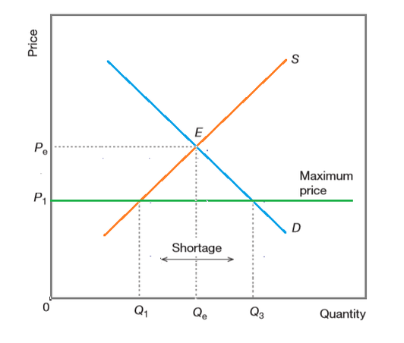

Minimum price
Minimum price: a price that is fixed; the market price must not go below this price.
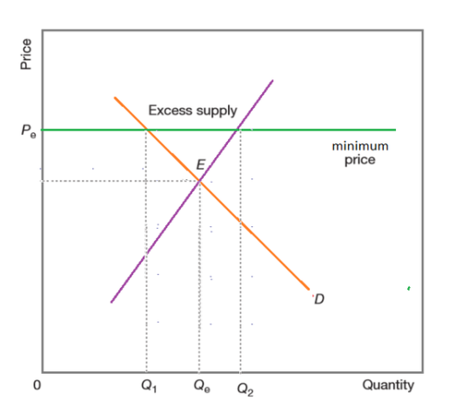
Questions:

Compare the likely effectiveness of a policy of imposing minimum prices on demerit goods with one other policy to improve public health and consider which policy is more likely to be successful. [12] | 9708/22/M/J/21
Explain, with the help of a diagram, how a free market would react if a minimum price which had been set above the equilibrium is removed. [8] | 9708/21/O/N/19
Explain, with the help of a diagram, the disadvantages to consumers of introducing a maximum price in a market for an essential food item.[8 | 9708/21/M/J/19
Discuss whether the imposition of maximum prices can improve the allocation of scarce resources.[12] | 9708/22/F/M/19
Discuss the difficulties of introducing a widespread system of maximum prices for essential food to protect low-income families in a period of high inflation. Consider whether this system is likely to be successful.[12] | 9708/21/M/J/17

Aggregate demand and aggregate supply

Highlighted Keywords:

Aggregate demand
Aggregate demand (AD): the total spending on an economy’s goods and services at a given price level in a given time period.

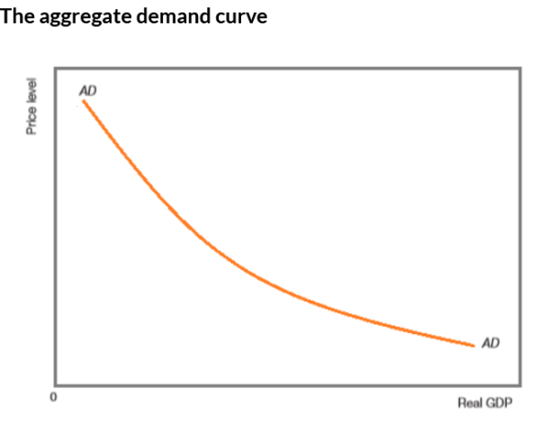

Aggregate supply
Aggregate supply (AS): the total output (real GDP) that producers in an economy are willing and able to supply at a given price level in a given time period.

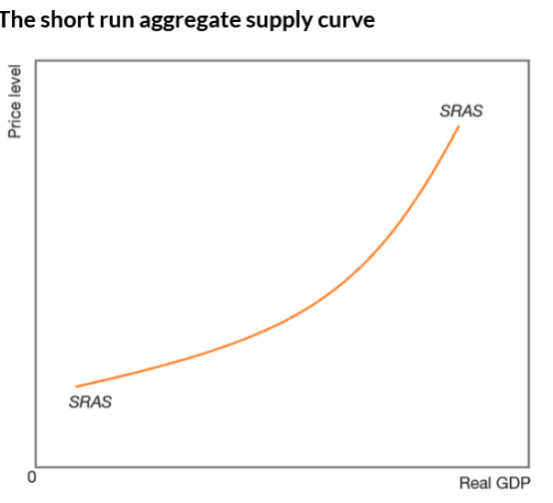

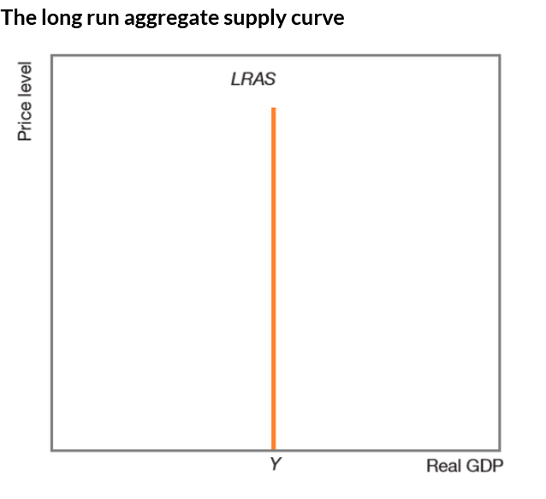

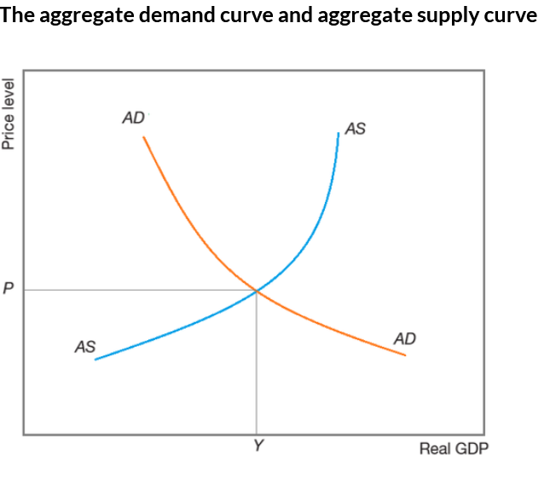
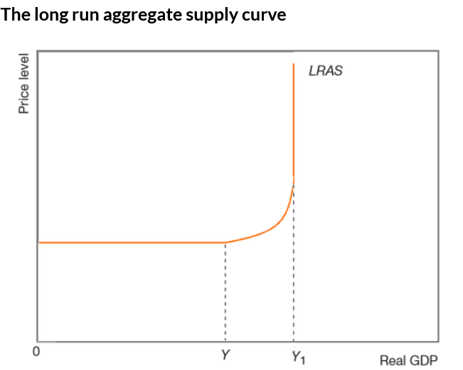

Questions:

Explain how the factor of production enterprise contributes to aggregate supply in a modern economy and how it differs from the other factors of production in terms of the reward for its services.[8] | 9708/22/O/N/20
Explain how aggregate demand is likely to be affected by an increase in the money supply and consider whether the impact of such an increase will be on employment or on the general price level. [12] | 9708/22/O/N/20
Explain, with the help of a diagram, the difference between what causes (i) a movement along an aggregate supply curve and (ii) a shift in an aggregate supply curve.[8] | 9708/21/O/N/19
Explain, with the help of a diagram(s), how changes in aggregate demand and aggregate supply can cause inflation in an economy.[8] | 9708/21/M/J/19
Discuss the causes of an increase in aggregate demand. Assess whether such an increase will always cause inflation. Use diagrams to support your answer.[12 | 9708/21/O/N/17

Government intervention

Highlighted Keywords:

Fiscal policy
Fiscal policy is the use of taxation and government spending to influence aggregate demand

Monetary policy
Monetary policy is the use of interest rates, direct control of the money supply and the exchange rate to influence aggregate demand.

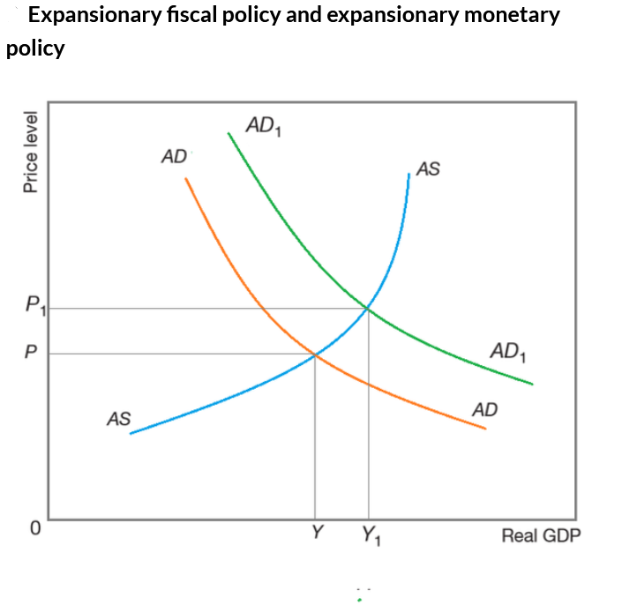
Supply side policy
Supply side policies are measures designed to increase aggregate supply
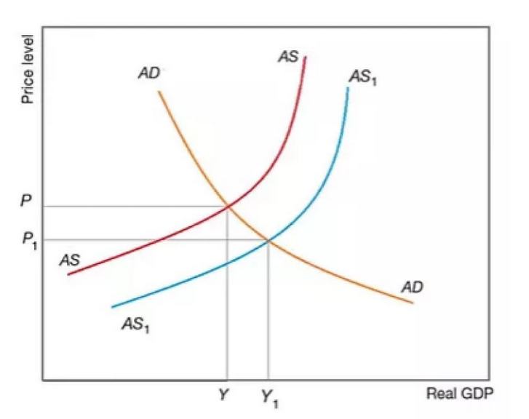

Questions:

Discuss whether a government should use monetary policy or fiscal policy to solve the problem of deflation in an economy. [12] | 9708/22/M/J/21
Discuss whether supply-side policies are likely to be effective in increasing employment in an economy.[12] | 9708/21/O/N/19
Discuss the problems in applying supply-side policies in an economy and assess whether these problems can be overcome.[12] | 9708/22/O/N/19
Analyse how fiscal policy and monetary policy could be used to solve the problem of deflation. Assess which policy is likely to be more effective.[12] | 9708/22/O/N/18
Discuss whether increased government spending on a country’s infrastructure will always lead to a rise in the rate of inflation. Use aggregate demand and aggregate supply analysis to support your answer.[12] | 9708/22/O/N/18
Discuss how supply-side policies might increase the stock of capital goods and the quantity of labour supplied to an economy. Consider whether these policies will be effective for each of these factors of production.[12] | 708/22/F/M/18
Explain the difference between fiscal policy and monetary policy. Show how each can be used to increase aggregate demand.[8 | 9708/22/M/J/17
Discuss whether supply side policy is more likely to be successful than fiscal policy when an economy is faced with inflation.[12] | 9708/22/M/J/17
Discuss the use of supply side policy as a means of solving the problem of inflation. Consider whether this policy is likely to be effective.[12] | 9708/21/M/J/17

Inflation and deflation

Highlighted Keywords:

Inflation
Inflation is a sustained increase in an economy’s price level.

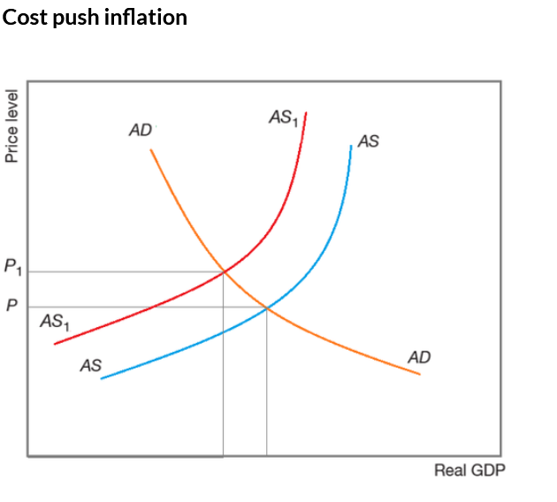
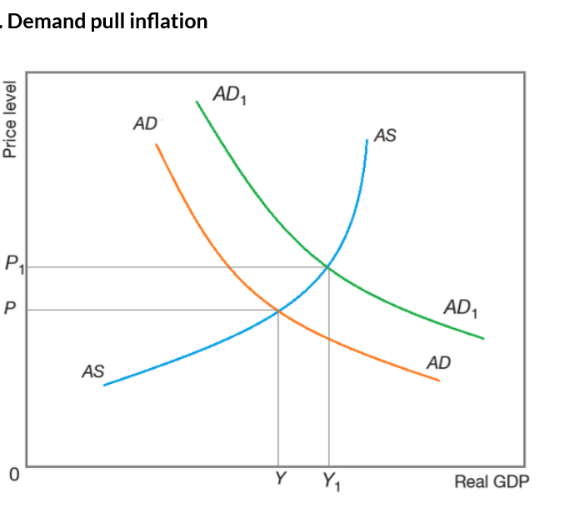
Deflation
Deflation is a sustained fall in the price level
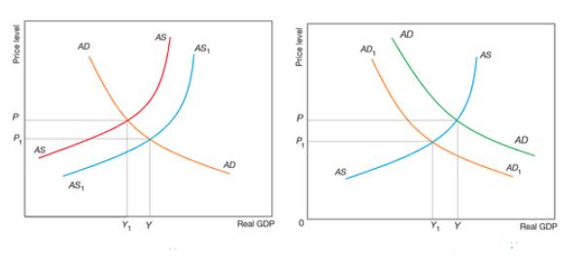

Questions:

Explain what is meant by deflation and use aggregate demand and aggregate supply diagrams to explain how it might arise in an economy. [8] | 9708/22/M/J/21
Discuss whether deflation is more of a problem in an economy than inflation.[12] | 9708/21/M/J/19
Explain how the rate of deflation is measured and the impact of a period of deflation on an economy. [8] | 9708/22/O/N/18
Discuss the consequences of high inflation. Consider whether the internal consequences can ever be more serious than the external consequences in an economy that has extensive foreign trade.[12] | 9708/22/F/M/17

Exchange rates

Highlighted Keywords:

Depreciation
Depreciation: a decrease in the international price of a currency caused by market forces.

Appreciation
Appreciation: an increase in the international price of a currency caused by market forces.

Exchange rate and Inflation
Typically, a country with a consistently lower inflation rate exhibits a rising currency value, as its purchasing power increases relative to other currencies. Those countries with higher inflation typically see depreciation in their currency about the currencies of their trading partners.
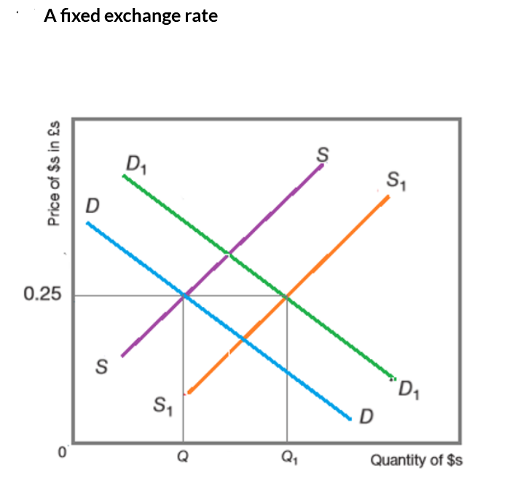
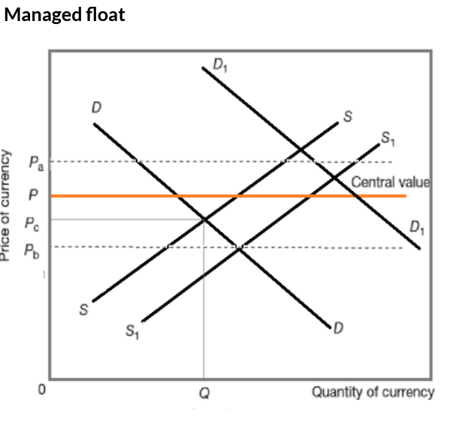

Questions:

Explain, with the aid of a diagram, one demand factor and one supply factor that can cause the depreciation of a foreign exchange rate.[8] | 9708/21/M/J/20
Discuss whether an appreciation of a country’s foreign exchange rate is likely to cause both a rise in inflation and a decrease in employment in its economy.[12] | 9708/21/M/J/20
Explain how a government can reduce the value of the exchange rate in an economy with a managed exchange rate system. [8] | 9708/22/F/M/19
Explain how a high rate of inflation and a rise in an economy’s exchange rate can each cause a deficit in an economy’s current account of the balance of payments.[8] | 9708/22/M/J/18
Explain how a fall in an economy’s foreign exchange rate can cause both cost-push and demand-pull inflation.[8] | 9708/21/M/J/17

Terms of trade

Highlighted Keywords:

Terms of trade
Terms of trade is a numerical measure of the relationship between export and import prices.

Terms of trade index = index of export prices ×100
index of import prices
Questions
China’s terms of trade index fell from 102.1 in March 2018 to 99.7 in April 2018.(a)State how the terms of trade are measured, and explain three possible causes of the fall in China’s terms of trade shown above.[8] | 9708/22/O/N/20
China’s terms of trade index fell from 102.1 in March 2018 to 99.7 in April 2018 (b)Discuss whether a rise in the terms of trade or a fall in the terms of trade is more likely to be of benefit for an economy.[12 | 9708/22/O/N/20
Explain how the terms of trade of an economy will be affected by changes in that economy’s exchange rate.[8] | 9708/22/O/N/19
Describe what is meant by a rise in an economy’s terms of trade. Outline how a change in an economy’s exchange rate and its domestic price level might each cause this to come about.[8] | 708/22/F/M/18
Discuss whether a rise in an economy’s terms of trade is likely to be of overall benefit to that economy.[12] | 708/22/F/M/18

International trade

Highlighted Keywords:

Expenditure-reducing policy
Expenditure dampening or reducing policy: policy measures designed to reduce imports and increase exports by reducing demand

Expenditure-switching policy
Expenditure switching policy: policy measures designed to encourage people to switch from buying foreign-produced products to buying domestically produced products.

Free Trade
Free trade: international trade not restricted by tariff s and other protectionist measures.

Protectionism
Protectionism involves protecting domestic industries from foreign competition.

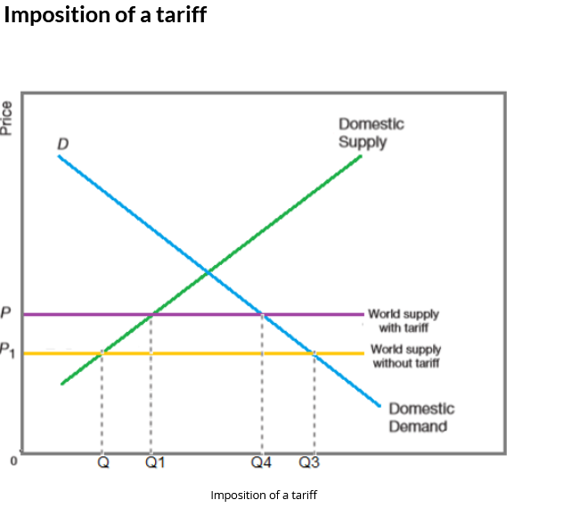

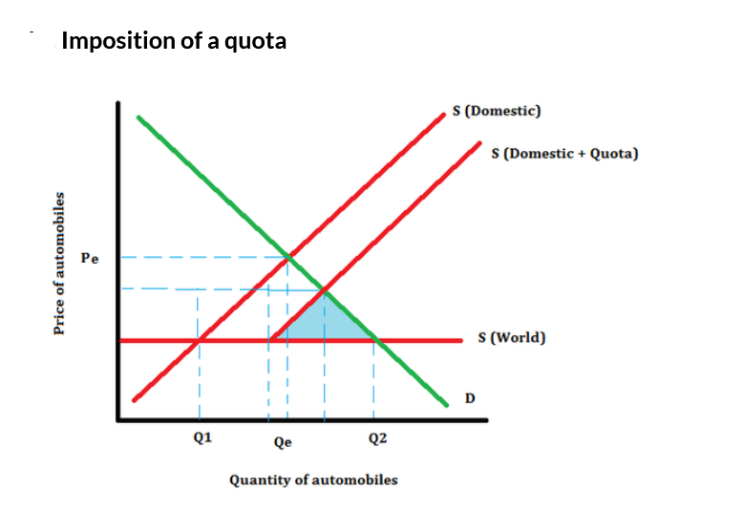
Current account deficit
The current account balance is the overall balance of the trade in goods, trade in services, income and current transfers. A current account deficit means that the combined debit items on the four parts exceed the combined credit items on the four parts

Questions:

Discuss, using examples, whether an expenditure-reducing or an expenditure-switching policy is the more effective response in economies faced with a deficit on the current account of the balance of payments. [12] | 9708/22/O/N/19
Discuss the advantages and disadvantages of using expenditure-reducing policies to remove a deficit on the current account of the balance of payments and consider the likelihood that such policies will be successful. [12] | 9708/22/F/M/19
Explain the difference in the way tariffs and quotas operate as methods of protection. [8] | 9708/21/O/N/18
Discuss the extent to which free trade should always be preferred to protectionism. [12] | 9708/21/O/N/18
Discuss whether a high rate of inflation or a deficit on the current account of the balance of payments is the more serious problem for an economy.[12] | 9708/22/M/J/18
Describe the four components of the current account of the balance of payments. Explain what might cause a deficit in this account.[8] | 9708/22/O/N/17
Discuss the ways in which expenditure-reducing and expenditure-switching policies attempt to remove a current account deficit. Assess which approach is preferable.[12] | 9708/22/O/N/17

